**Townsview School Guidance Program:**

**April Newsletter**



](https://www.youtube.com/watch?v=wMPY2yOazb0)[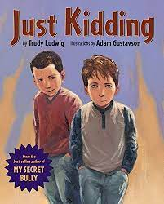](https://www.youtube.com/watch?v=NZZAGQcffVI)[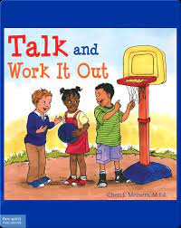](https://www.youtube.com/watch?v=d7_KhagiaOE)

**Family Connection: Try This at Home**

**K-2**

**Give your child a few scenarios that involve age-appropriate conflict. For example, your child is coloring, and another student grabs the marker to use. Ask your child how they would feel in this situation. What are some ways that this problem could be solved without going to the teacher first?**

**3-5**

**Tell your child about a problem or conflict you had with another person. How did you handle the problem? Could you have done something different? Ask your child if they have ever had a problem they were not sure how to solve. What did they do? Is there something they could have done to solve the problem in a better way?**

**6-8**

**Discuss with your child a conflict they have witnessed or been involved in recently. This could be personal, within their friend/class group, or a current event/issue. A popular difference of opinion lately has been surrounding the pandemic. Talk to your child about how it is ok to have a difference of opinion. Brainstorm together how they can have a meaningful conversation, while still respecting the other person’s opinions and perspectives.**

The read alouds below support the theme of the month. You can access each read aloud the following ways:

1. YouTube (click each photo to open the link).

2. Borrow a copy from the Guidance Office.

3. Purchase a copy from [www.Amazon.ca](http://www.Amazon.ca)

**Theme of the Month**

The school-wide focus for April is **Problem Solving(K-5)** and **Managing Relationships and Social Conflict (6- 8).** Problem Solving is the process of finding solutions to problems encountered in life. This process includes defining a problem, determining the cause of the problem, identifying a solution, and implementing that solution. Managing Relationships and Social Conflict allows students to learn the ways that they can maintain a healthy relationship and use strategies and problem solving during social conflict in an appropriate way.

The behavior of focus for all students will be ‘**Patience’**. During the month of April, students will learn the importance of tolerating delay without getting angry or upset.

**Guidance Program**

Throughout April, guidance will continue supporting and enhancing student learning through academic, social-emotional, and career development. The ESS (Guidance) teacher supports whole school initiatives (such as the Second Step and Link Program), by providing resources, activities, co- planning, co-teaching, and offering small group/individual learning opportunities related to general guidance curriculum outcomes (such as emotional regulation and friendship groups). If you have any questions about the guidance program at TVS, please feel free to contact me at the school: 506-325-4435 or [Jessica.Irvine@nbed.nb.ca](mailto:Jessica.Irvine@nbed.nb.ca).

Jessica Irvine